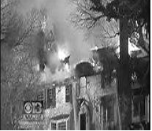

Don’t let this happen at your house.
Are you prepared?

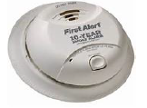

Smoke Detectors and Carbon Monoxide Detectors

Two groups join forces to meet with you and help make sure you have a functioning detector.
Just email us to participate in the program at chahomeowners@gmail.com

Chartley Homeowners Association, Inc. Reisterstown Volunteer Fire Department

